Meeting 31

Course / Class #: CECS 4800

Date: 22 May 2014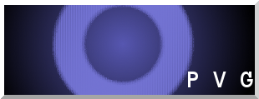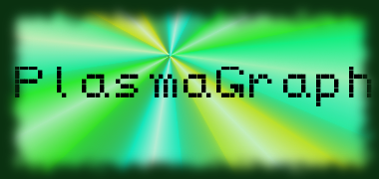

Project Name: PlasmaGraph

Has been done:

1. Work on SDD
2. Finished version of SPMP
3. Poster’s first draft
4. Finished version of STD
5. Finished version of TDS-02-XX

What will be done:

1. Finish version of TDS-01-XX
2. Perform all the tests specified by the STD
3. Finish SDD.
4. Finish Poster.
5. Make the project’s presentation.
6. Make the user’s manual
7. Make the installation manual

Materials Used: 2x Computers, Internet connections, Microsoft Visio / Dia (Diagramming Tools), Eclipse / NetBeans IDE (Programming Tools).

Group Members: ________________________________

Gerardo A. Navas

________________________________

Daniel Quintini

Professor:

________________________________

Prof. Luis A. Ortiz